1.Draw a labelled diagram of a typical home WiFi router and a network switch, clearly marking at least 3 different ports (such as WAN, LAN, Console) and the location of status LEDs.

->
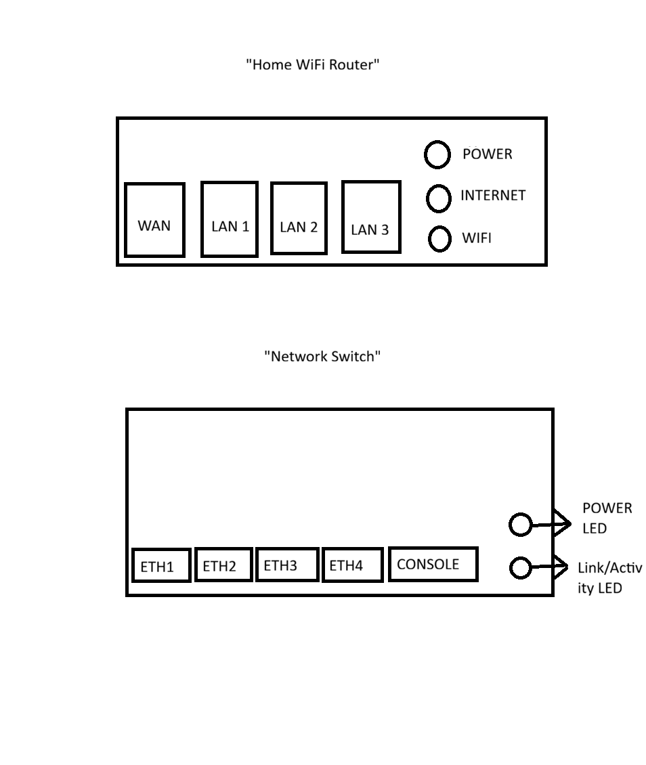
2.List 3 key differences between routers and switches in terms of their main functions and how they handle network traffic.<br><br><em><strong>Hint:</strong> Think about how each device deals with IP addresses, MAC addresses, and the types of networks they connect.</em>

Feature | Router | Switch
Main Function | A router connects different networks, such as a home network to the Internet. | A switch connects devices within the same network, such as computers and printers.
Address Used | A router uses IP addresses to send data between networks. | A switch uses MAC addresses to send data to devices on the same network.
Network Traffic Handling | A router forwards data packets between different networks. | A switch sends data only to the specific device for which it is intended within a local network.

3.Take a real or virtual image of a router and a switch (from your home, lab, or Google Images), and identify the following on each: Power port, at least 2 Ethernet ports, and any LED indicators. Annotate the image or describe their position and purpose.

->Router

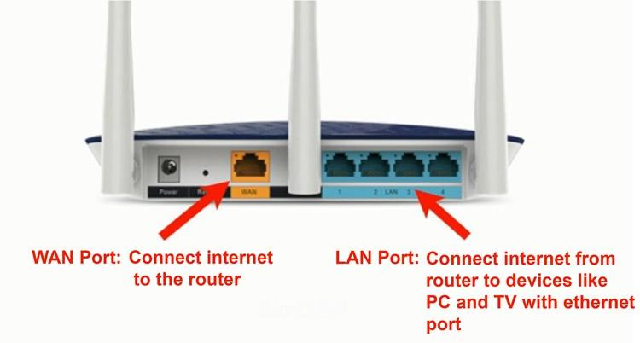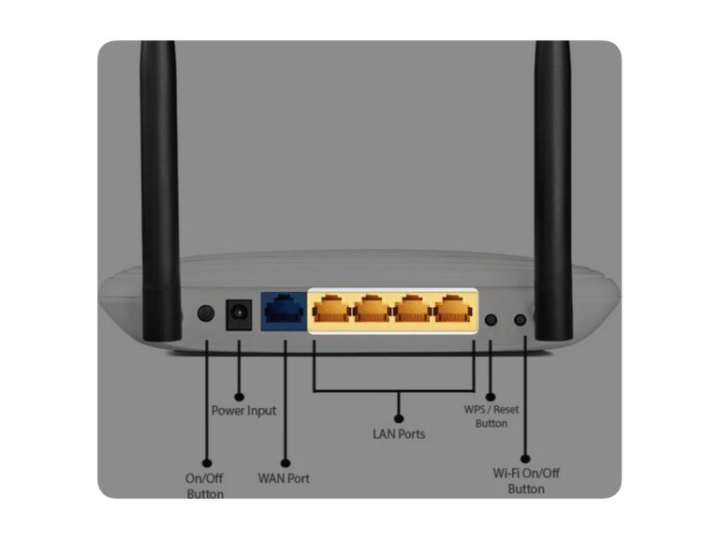
- Power Port – The power port is usually located at the back side of the router. It is used to connect the power adapter and supply electricity to the router.
- Ethernet Port 1 (WAN Port) – The WAN port is generally blue in color and is present on the back panel. It is used to connect the router to the Internet modem.
- Ethernet Port 2 (LAN Port) – The LAN ports are usually yellow and located next to the WAN port. They are used to connect computers, laptops, or other devices to the local network.
- LED Indicators – LED lights are normally found on the front or top side of the router. Common LEDs include:
  - Power LED – Shows whether the router is turned on.
  - Internet LED – Indicates Internet connectivity.
  - WiFi LED – Shows the status of the wireless network.

Network Switch

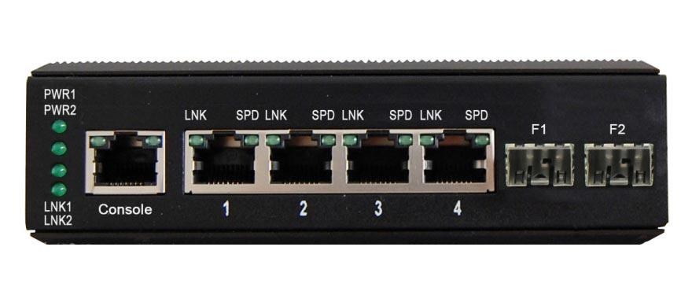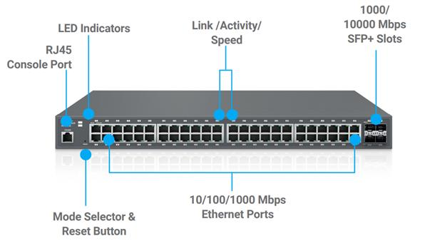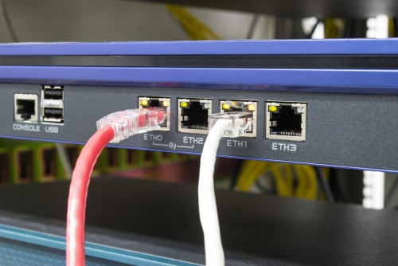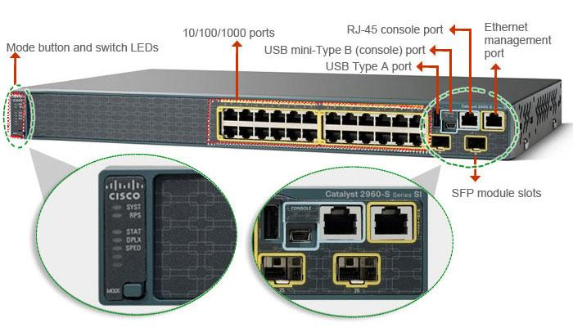
- Power Port – The power port is usually located at the back side of the switch. It provides power to the device.
- Ethernet Port 1 – Ethernet ports are located on the front panel of the switch. They are used to connect computers and other network devices.
- Ethernet Port 2 – Additional Ethernet ports are also available on the front panel to connect multiple devices within the same network.
- LED Indicators – LED lights are generally located near the Ethernet ports.
  - Power LED – Indicates that the switch is powered on.
  - Link/Activity LED – Shows whether a device is connected and if data is being transmitted.
4.Imagine you are setting up a small gaming café network for IPL streaming and multiplayer matches. Write a short scenario explaining which device (router or switch) you would connect first to the ISP line, and how you would connect 8 gaming PCs to the network. Justify your choices.

->If I were setting up a small gaming café for IPL streaming and multiplayer games, I would first connect the router to the ISP (Internet Service Provider) line because the router provides Internet access to the entire network. After that, I would connect a network switch to one of the router's LAN ports.
To connect 8 gaming PCs, I would connect all 8 PCs to the switch using Ethernet cables. A switch is the best choice because it can connect multiple devices within the same local network and provide fast communication between the gaming PCs. This setup would ensure stable Internet access for IPL streaming and smooth multiplayer gaming with less network congestion.

